Instructions of QAVT

1. Introduce

QAVT is used for batch of execution. Recently it can compares decision tables, analyzes decision tables. It has expansibility, but limits for windows.

1. Usage
   1. Create your configuration( .ini file).

Format 1: QAVT.+ ComputerName+ _AnaDecision+[xxx]+.ini

Format 2: QAVT.+ ComputerName+ _CmpDecision+[xxx]+.ini

*Notes*

*How to get ComputerName? Open CMD, type hostname, and you can see your ComputerName in console.*

*Red font in format means it can be modified, black font in format means it cannot be modified.*

*If you don’t want to run job (i.e. AnaDecision job) in your computer, and don’t want to delete it, you can modify black font in format. And this job will not be running.*

i.e. 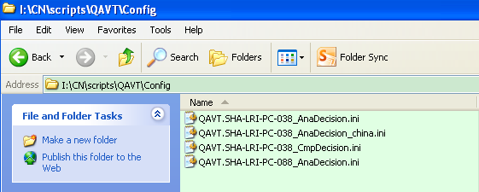

* 1. Type the information into configuration, or copy this information from old configuration.

All variants in QAVT have common meanings.

* + 1. AnaDecision job

It can use the background color to mark the repeated decision rule in the same STBITEM or intersection. Also provide a log.

The variant **_QAVT_CONFIG_FORM**‘s value can be an array, separating character is comma. If database *CN_4209_0912_SYSTEM* have tables *G01_CHILD, G01_MASTER*, and you want to do AnaDecision job on return *G01*, the variant should like this: *_QAVT_CONFIG_FORM=G01*

i.e.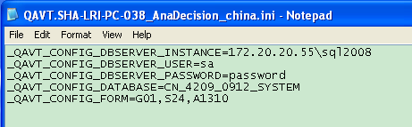

* + 1. CmpDecision job

It can compare decision tables in two databases, mark which record are new added or deleted or modified.

The variant **_QAVT_CONFIG_DBSERVER_TYPE** ‘s value is oracle or sql.

Specially, using variant **_QAVT_CONFIG_DBSERVER_INSTANCE** for Oracle’s User/Schema.

i.e.

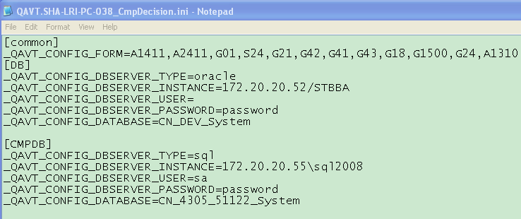

* 1. Copy an shortcut to QAVTSETUP.BAT(“I:\CN\scripts\QAVT\Shortcut to QAVTSETUP.BAT.lnk”) on your local computer
  2. Double click the Shortcut, and you can see an cmd is running.
  3. After CMD window prompts “QAVT.bat -- Finished Running. ^o^”, you can find results on %SystemDrive%\QAVT_Auto\QAVT.Output

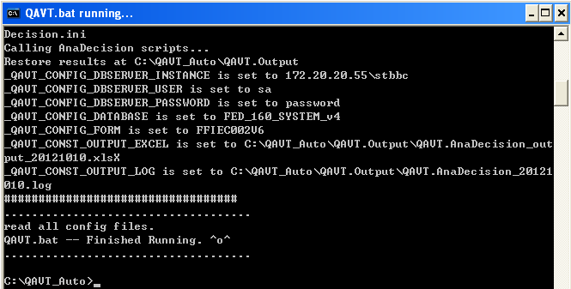

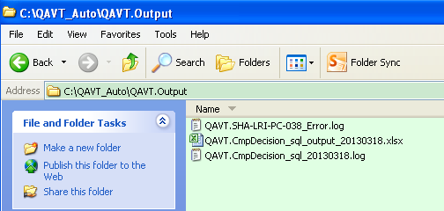

1. Q&A

Any question/defect please email Kun.Shen@lombardrisk.com